Nguyễn Lê Thịnh_1250080186_CNTT4
Bài Tập Lý Thuyết Buổi 4

-- 1. PHONGBAN
create table PHONGBAN (
MAPHONG int primary key,
TENPHONG varchar2(50),
TRUONGPHONG int,
NGAYNHANCHUC date
);

-- 2. NHANVIEN
create table NHANVIEN (
MANV int primary key,
HONV varchar2(50),
TENNV varchar2(50),
NGAYSINH date,
DIACHI varchar2(50),
PHAI varchar2(10),
LUONG int,
MANQL int,
PHONG int,
constraint FK_PHONG_NV foreign key (PHONG) references PHONGBAN(MAPHONG),
constraint FK_NQL foreign key (MANQL) references NHANVIEN(MANV)
);

alter table PHONGBAN add constraint FK_TRUONGPHONG foreign key (TRUONGPHONG) references NHANVIEN(MANV);

-- 3. DIADIEMPHONG
create table DIADIEMPHONG (
MAPHONG int,
DIADIEM varchar2(50),
primary key (MAPHONG, DIADIEM),
constraint FK_DDP_PHONG foreign key (MAPHONG) references PHONGBAN(MAPHONG)
);

-- 4. DEAN
create table DEAN (
MADA int primary key,
TENDA varchar2(50),
DDIEMDA varchar2(50),
PHONG int,
constraint FK_DEAN_PHONG foreign key (PHONG) references PHONGBAN(MAPHONG)
);

-- 5. PHANCONG
create table PHANCONG (
MANV int,
MADA int,
THOIGIAN number(10,2),
primary key (MANV, MADA),
constraint FK_PC_NV foreign key (MANV) references NHANVIEN(MANV),
constraint FK_PC_DA foreign key (MADA) references DEAN(MADA)
);

-- 6. THANNHAN
create table THANNHAN (
MATN int primary key,
HOTN varchar2(50),
TENTN varchar2(50),
PHAI varchar2(10),
NGAYSINH date
);

-- 7. NVIEN_TNHAN
create table NVIEN_TNHAN (
MANV int,
MATN int,
QUANHE varchar2(50),
primary key (MANV, MATN),
constraint FK_NVTN_NV foreign key (MANV) references NHANVIEN(MANV),
constraint FK_NVTN_TN foreign key (MATN) references THANNHAN(MATN)
);

--- CHÈN DỮ LIỆU ---

insert into PHONGBAN values (1, 'HANH CHINH', null, to_date('2020-01-01', 'yyyy-mm-dd'));
insert into PHONGBAN values (2, 'TAI VU', null, to_date('2021-03-10', 'yyyy-mm-dd'));

insert into NHANVIEN (MANV, HONV, TENNV, NGAYSINH, DIACHI, PHAI, LUONG, MANQL, PHONG)
values (1, 'NGUYEN LE', 'THINH', to_date('1990-05-15', 'yyyy-mm-dd'), 'TP HCM', 'NAM', 600000, null, 1);

insert into NHANVIEN (MANV, HONV, TENNV, NGAYSINH, DIACHI, PHAI, LUONG, MANQL, PHONG)
values (2, 'HO ANH', 'KHOA', to_date('1995-10-20', 'yyyy-mm-dd'), 'CAN THO', 'NAM', 550000, 1, 2);

insert into NHANVIEN (MANV, HONV, TENNV, NGAYSINH, DIACHI, PHAI, LUONG, MANQL, PHONG)
values (3, 'PHAM', 'HUYNH', to_date('1988-12-30', 'yyyy-mm-dd'), 'DA NANG', 'NAM', 700000, 1, 1);

-- Thêm nhân viên Nữ
insert into NHANVIEN (MANV, HONV, TENNV, NGAYSINH, DIACHI, PHAI, LUONG, MANQL, PHONG)
values (4, 'LE THI', 'HOA', to_date('1997-08-12', 'yyyy-mm-dd'), 'TP HCM', 'NU', 520000, 1, 1);

update PHONGBAN set TRUONGPHONG = 1 where MAPHONG = 1;
update PHONGBAN set TRUONGPHONG = 2 where MAPHONG = 2;

insert into DEAN values (10, 'DA01', 'QUAN 1', 1);
insert into DEAN values (20, 'DA02', 'QUAN 3', 2);

insert into PHANCONG values (1, 10, 35.0);
insert into PHANCONG values (4, 10, 25.0); -- Nhân viên nữ tham gia đề án DA01
insert into PHANCONG values (2, 20, 15.0);

insert into THANNHAN values (50, 'NGUYEN LE', 'THINH', 'NAM', to_date('2020-01-01', 'yyyy-mm-dd'));
insert into NVIEN_TNHAN values (1, 50, 'CON TRAI');

commit;

--- TRUY VẤN ---
-- 1
select * from NHANVIEN where TENNV = 'HUYNH';
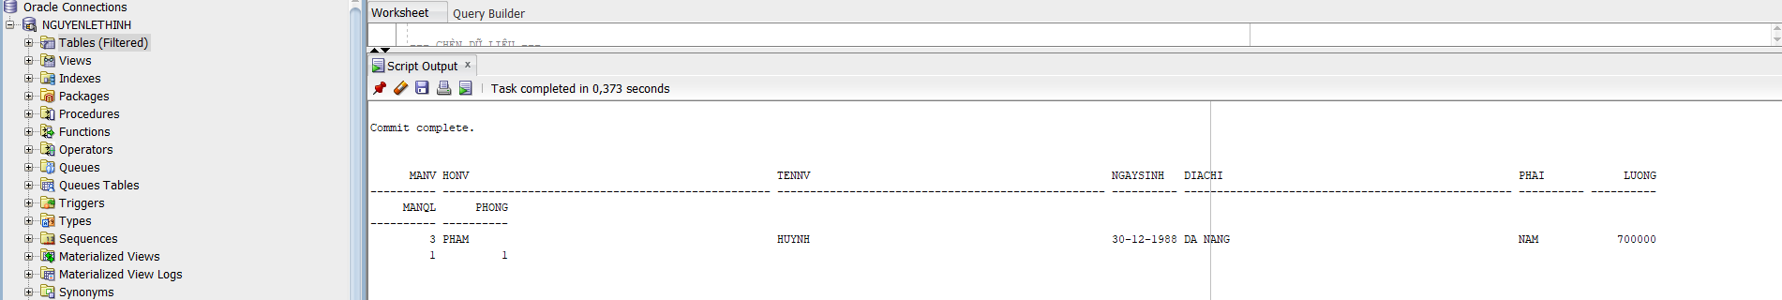

-- 2
select NV.MANV, NV.HONV || ' ' || NV.TENNV as HOTEN, NV.DIACHI
from NHANVIEN NV join PHONGBAN PB on NV.PHONG = PB.MAPHONG
where PB.TENPHONG = 'HANH CHINH';
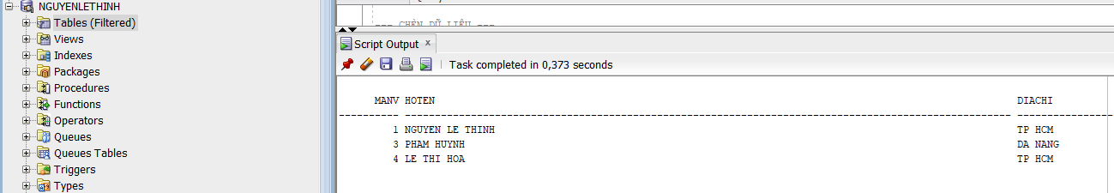
-- 3
select NV.MANV, NV.HONV || ' ' || NV.TENNV as HOTEN, NV.DIACHI
from NHANVIEN NV join PHONGBAN PB on NV.PHONG = PB.MAPHONG
where PB.TENPHONG in ('HANH CHINH', 'TAI VU');
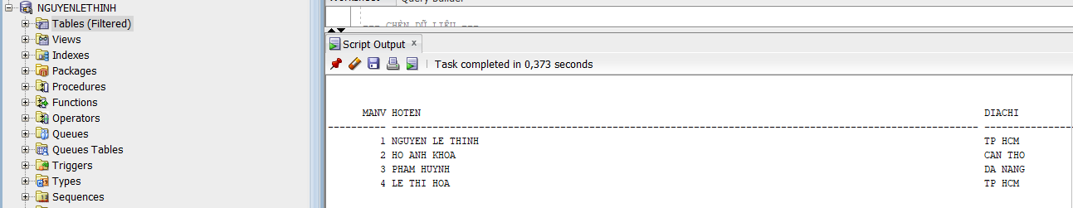
-- 4
select NV.MANV, NV.HONV || ' ' || NV.TENNV as HOTEN, DA.TENDA
from NHANVIEN NV join PHANCONG PC on NV.MANV = PC.MANV join DEAN DA on PC.MADA = DA.MADA;
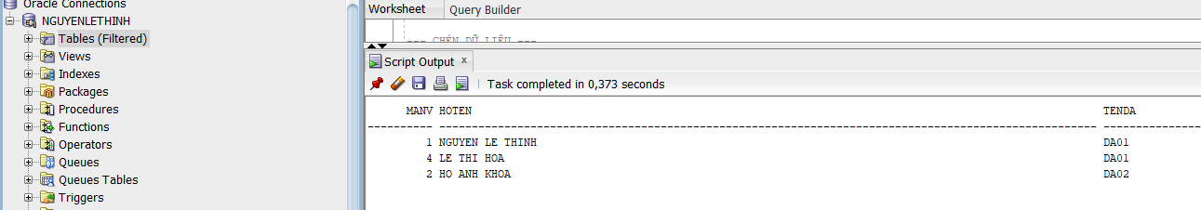
-- 5
select DA.MADA, DA.TENDA, PB.TENPHONG, TP.MANV as MATP, TP.HONV || ' ' || TP.TENNV as TENTP
from DEAN DA join PHONGBAN PB on DA.PHONG = PB.MAPHONG join NHANVIEN TP on PB.TRUONGPHONG = TP.MANV;
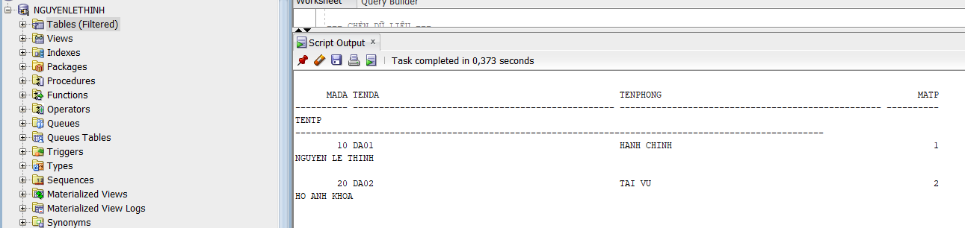
-- 6
select NV.MANV, NV.HONV || ' ' || NV.TENNV as HOTEN
from NHANVIEN NV join PHANCONG PC on NV.MANV = PC.MANV join DEAN DA on PC.MADA = DA.MADA
where DA.TENDA = 'DA01' and PC.THOIGIAN > 30;
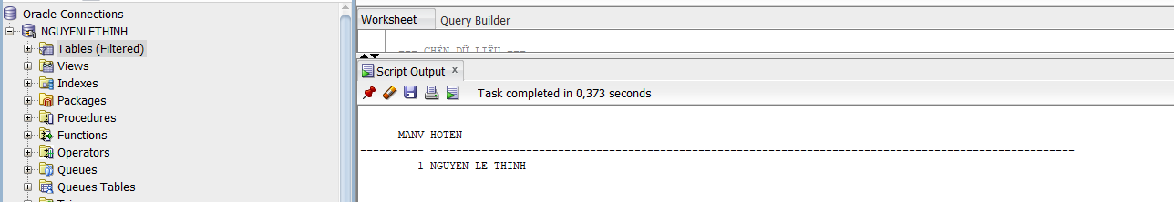
-- 7
select NV.MANV, NV.HONV || ' ' || NV.TENNV as HOTEN
from NHANVIEN NV join NVIEN_TNHAN NT on NV.MANV = NT.MANV join THANNHAN TN on NT.MATN = TN.MATN
where NV.TENNV = TN.TENTN;
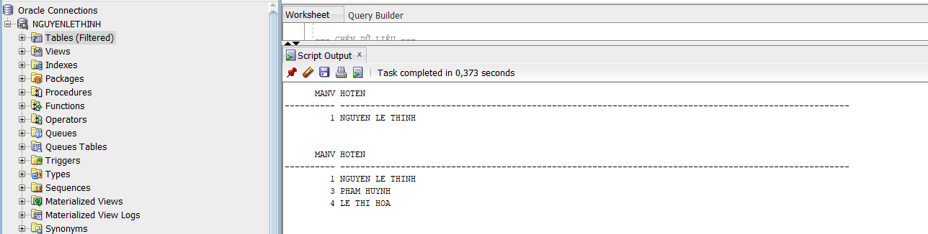
-- 8
select NV.MANV, NV.HONV || ' ' || NV.TENNV as HOTEN
from NHANVIEN NV join PHONGBAN PB on NV.PHONG = PB.MAPHONG join NHANVIEN TP on PB.TRUONGPHONG = TP.MANV
where TP.HONV = 'NGUYEN LE' and TP.TENNV = 'THINH';

-- 9
select NV.MANV, NV.HONV || ' ' || NV.TENNV as HOTEN
from NHANVIEN NV join NHANVIEN QL on NV.MANQL = QL.MANV
where QL.HONV = 'NGUYEN LE' and QL.TENNV = 'THINH';
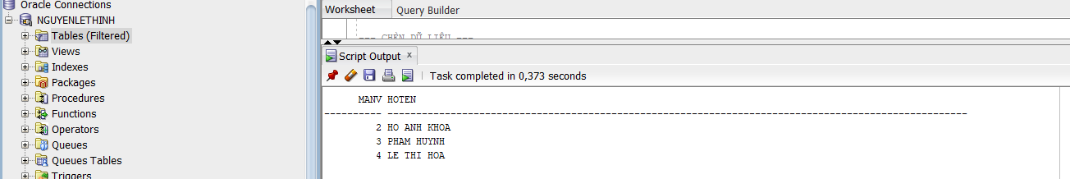
-- 10
select MANV, HONV || ' ' || TENNV as HOTEN from NHANVIEN NV
where not exists ((select MADA from DEAN) minus (select MADA from PHANCONG PC where PC.MANV = NV.MANV));

-- 11
select MANV, HONV || ' ' || TENNV as HOTEN from NHANVIEN
where MANV not in (select distinct MANV from PHANCONG);
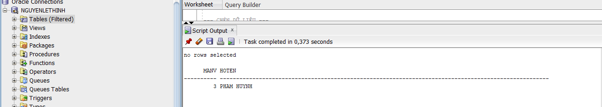
-- 12
select avg(LUONG) as LUONG_TB from NHANVIEN;
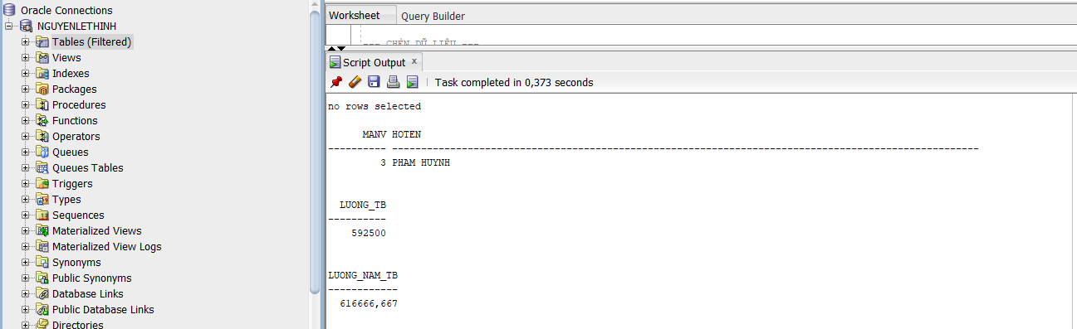

-- 13
select avg(LUONG) as LUONG_NAM_TB from NHANVIEN where PHAI = 'NAM';
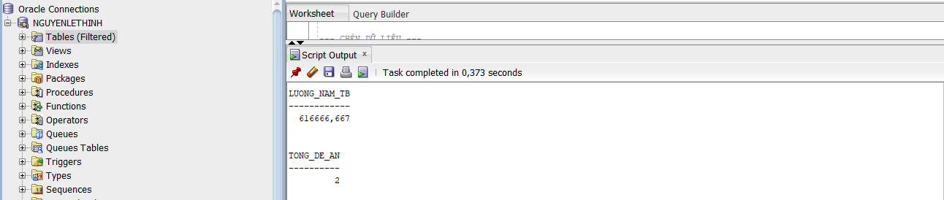
-- 14
select count(*) as TONG_DE_AN from DEAN;

-- 15
select MADA, count(MANV) as SO_NV from PHANCONG group by MADA;
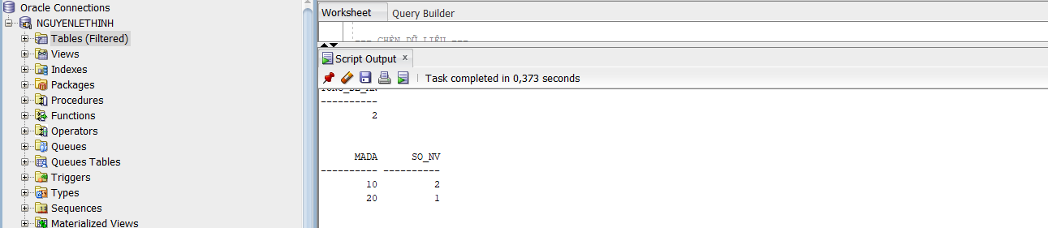
-- 16
select PC.MADA, count(NV.MANV) as SO_NV_NU
from PHANCONG PC join NHANVIEN NV on PC.MANV = NV.MANV
where NV.PHAI = 'NU' group by PC.MADA;
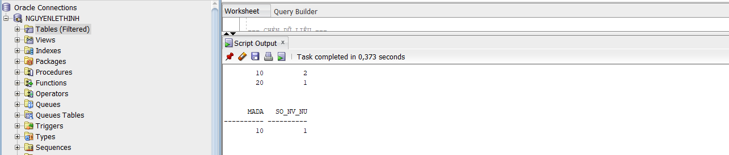
-- 17
update PHANCONG set THOIGIAN = THOIGIAN + 4
where MANV in (select MANV from NHANVIEN where PHAI = 'NAM');
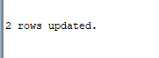
-- 18
delete from NHANVIEN where LUONG < 500000;
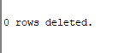
commit;

